**The Ultimate Web Design Process in 10 Simple Steps**

A Short Guide to Everything You Need to Know About the Web Design Process

Designing and developing a successful website that reaches its goal depends on good communication, planning, and a very skillful team behind the design and functionality. Needless to say, this is not an easy process, however, **having a consistent web design process can help you complete any project way smoother**.

Whether you prefer to adopt the [**double-diamond design process**](https://htmlburger.com/blog/double-diamond-design-process/) or the[**iterative approach**](https://htmlburger.com/blog/iterative-design-process-explained/), having a design process gives you structure, focus, and direction on how to go from an ambiguous problem to a complete design solution.

This is why in this blog post, we’ll share our **10-step web design process that will help you deliver websites faster and more efficiently.**

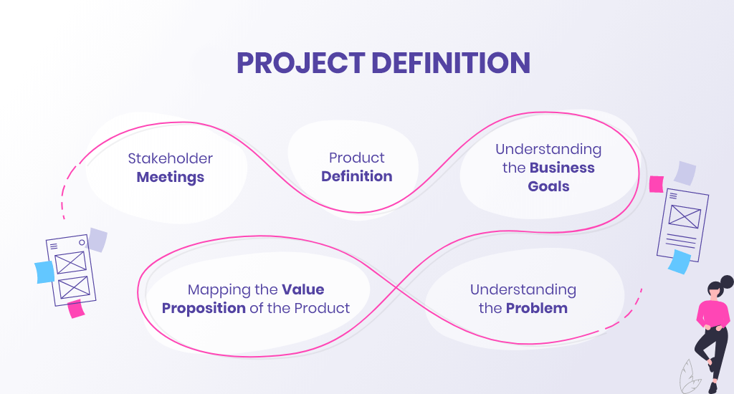

**1. Project Definition**

The first stage serves to**determine the goal of the website and what its design needs to accomplish** in order to meet that goal. Usually, during this phase, the project manager or the designer collaborates with stakeholders such as the agency that commissions the design, or the end client.

**✅ The Project Definition Step Includes:**

* Stakeholder meetings
* Product definition
* Understanding the business goals
* Mapping the value proposition of the product
* Understanding the problem

Every design process starts with the existence of a problem. Before designers develop a solution, they must **understand the problem they are trying to solve and the objectives they want to achieve**.

For example, if you’re contacted by an agency that wants you to redesign its website, you’re already at the starting point. This means you’re aware there’s a problem with the current design that you need to resolve in the new design.

This is mainly a research stage, where you **conduct interviews, get to understand the user’s needs, analyze the competition, and gather all the necessary data**. The goal is to define the project by brainstorming the purpose of the product as well as clarifying its value proposition, how it solves users’ problems and what are competitive advantages.

**✅ Questions to explore:**

* **Who is the target audience?**
* **What should the visitor expect to see** when they arrive at the website?
* **What is the primary purpose of the website?** Does it aim to sell, promote, educate, inform, entertain, serve as a platform, or something else?
* **How will the website differentiate from the competitors** in terms of problem-solving, value proposition, and experience?
* **Is there a specific problem the business solves for the target audience** and how it solves that problem?
* **What is the message** that the design needs to convey to the visitors?
* **What are the specific measurable goals** that the site should achieve? (These are the clear goals that will provide the most impact and move the organization forward.)

This leads us to the next important step that will guarantee a successful design process.

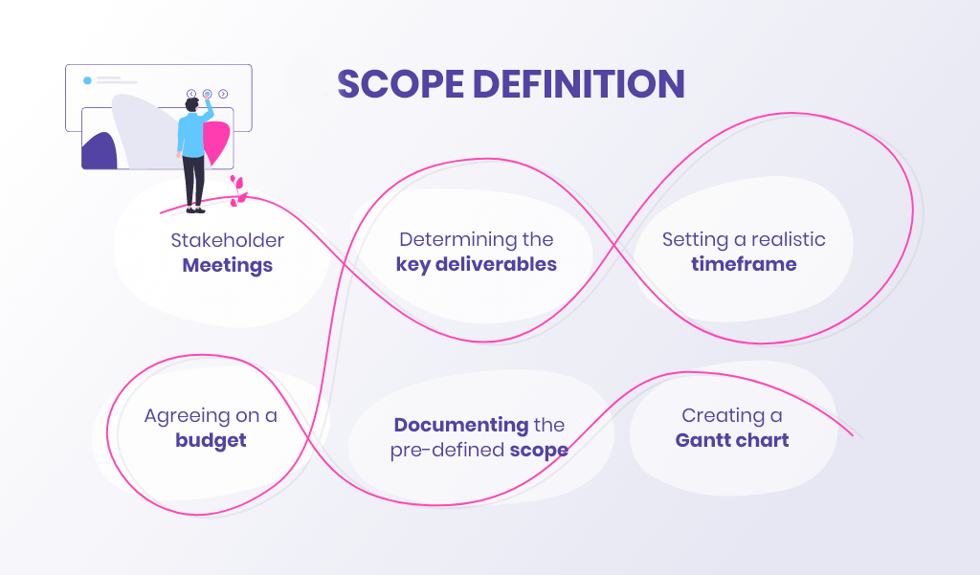

**2. Scope Definition**

Defining the **specific measurable goals in advance** will prevent the most dreaded scope creep. Imagine you start with one goal to design and code a website, but then the client decides to add an app, custom email templates, a landing page, push notifications, etc. This not only becomes a problem for designers to do more work out of the scope but also **the increased expectations no longer fit the timeframe and budget and, ultimately, become unrealistic.**

To prevent such a nightmare scenario, the next step is to have a project kick-off meeting by the end of which all stakeholders should be **on the same page regarding what the key deliverables are**. This will set concrete expectations for the final product and will help **set a realistic timeline for completion**.

**✅ The Scope Definition Step Includes:**

* **Stakeholder meetings**
* **Determining the key deliverables**
* **Setting a realistic timeframe** that meets the specific deliverables
* **Agreeing on a budget** that meets the specific deliverables
* [**Documenting the pre-defined scope**](https://kitchen.co/blog/write-scope-of-work/)**or writing a formal agreement of all the work you will do on a project**.
* **Creating a Gantt chart** or other type of timeline data visualization.

With the risk of scope creep and miscommunication out of the way, there finally comes the good part: planning and visualizing the website.

**3. Content Creation**

It’s a common practice to leave the website copy for last. In most cases, you will be tasked to just design and code a number of specific pages with section templates and Lorem Ipsum text placeholders that the clients will copy or remove and fill later. However, common practice doesn’t mean good practice.

When you’re designing out of thin air without anything factual to put on the page, this may create problems later on as the content might not fit the design and structure well and will ultimately make maintaining the website more difficult.

Let’s be realistic. It’s very rare for the client to have planned the content in advance, especially the written copy. However, there’s still a way to create an efficient structure.

**✅ Here are a couple of ways to structure a page without having content:**

* **Inspiration:** Look at the most successful of the competitor’s websites and try to emulate some of their tactics.
* **Structure:** When you structure your pages, always think of where you’re going to put the specific elements of content, and in what order.
* **Always start from the homepage:** Being the most important page of the website, the homepage gives you leverage to direct visitors to other pages. Knowing what sort of content the inner pages have, you will also know their priority and, ultimately, in what hierarchy you’ll introduce them on the homepage.
* **Placeholders:** Some pieces of content aren’t crucial to the site structure, so you can easily use placeholder content for them to be filled later. Usually, these are contact info, case studies, menus, checkout pages, product descriptions, etc.

This phase revolves around getting a clear understanding of what kind of content you will include in the design.

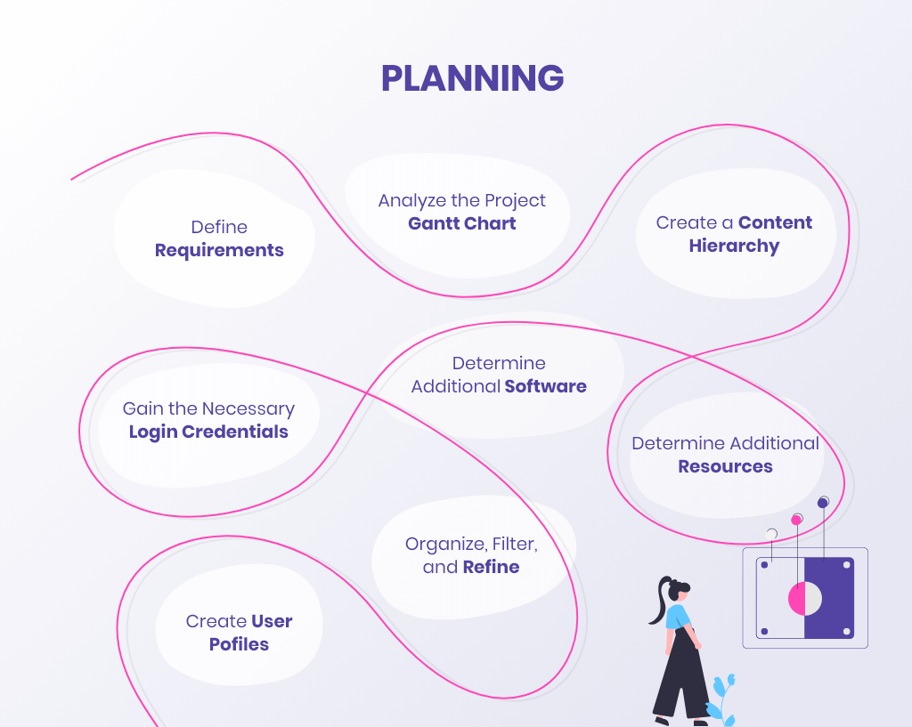

**4. Planning**

The planning phase refers to making decisions that will map the stage for your entire design process. Using all the information you’ve gathered from the brief with your clients, you can now outline your design strategy.

**✅ Planning includes the following:**

* **Requirements:**Narrowing down and prioritizing features; defining the project requirements; and analyzing the data from the brief.
* **Project Gantt chart:** Analyze the document that sums up all project requirements, deliverables, scope, and everything both parties have agreed on. It will serve as a reference point.
* **Content hierarchy:** In order to create the site map and information architecture, analyze what you’ve gathered from the previous step and plan your content hierarchy.
* **Gain the necessary access credentials:** If your project requires you to have an access to the client-server, a database of files, or any other library, make sure you have all log-in credentials needed, database configurations, or necessary frameworks installed in advance.
* **Software:** Determine any additional [software you may require](https://htmlburger.com/blog/web-design-tools/) and make sure it’s added to the project’s budget if needed.
* **Resources:** Determine all additional resources such as stock photos, fonts, or any other resources outside the initial project library.
* **Organizing**, filtering, and refining the gathered data down to the essence.
* **Creating user profiles.**

Now let’s get to designing the website.

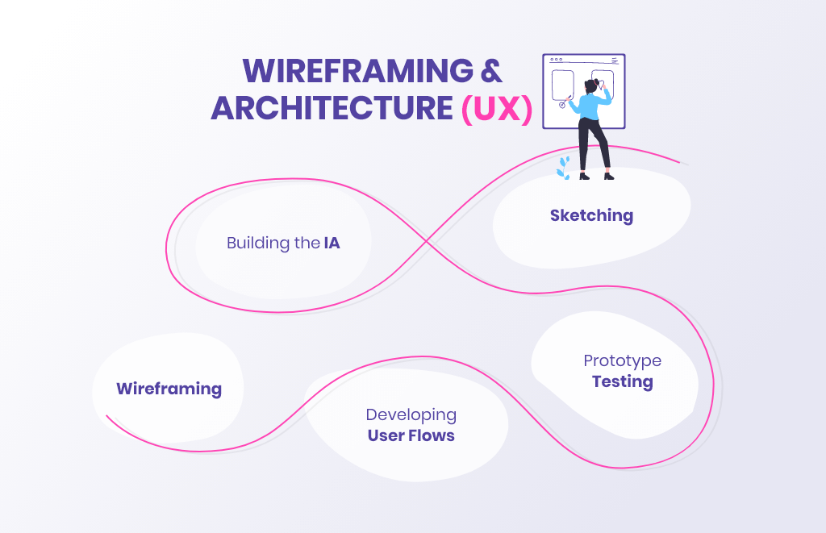

**5. Wireframing and Architecture (UX)**

Your next task is to create a user-friendly journey for the target audience. Before handling the visual design to make the web design attractive, intuitive, usable, and responsive, your task consists of the following:

**✅ Sketching:** Start with some quick sketches and low-fidelity designs to visualize your propositions for the final concept. This is mostly a brainstorming session where you will develop as many concepts as possible, get creative, and record ideas you can later present to the stakeholders.

**✅ Wireframing:** This step includes designing very simplified versions of the interface that focus on the layout and the basic elements. The wireframes are usually minimalistic, greyscale, and feature placeholders for the most important content.  These wireframes serve to communicate your most refined ideas to the stakeholders and collect valuable feedback.

**✅ Building the IA (Information Architecture):** With enough feedback and refining the design concept, your next step includes creating the very structure of the content in the final product.

**✅ Developing user flows:** The mapping process visualizes how the user will navigate through the product. This includes developing the different user journeys and user interactions.

**✅ Testing:**Testing allows you to improve your original design and eliminate all previously unforeseen issues and user difficulties.

*In the meantime, you can also check out the*[*UX design process, including how to start a UX project, and what specific UX steps you should take*](https://htmlburger.com/blog/ux-design-process-explained/)*in order to deliver a successful design solution.*

After the wireframes, structure, and user flows are approved, proceed with the visuals.

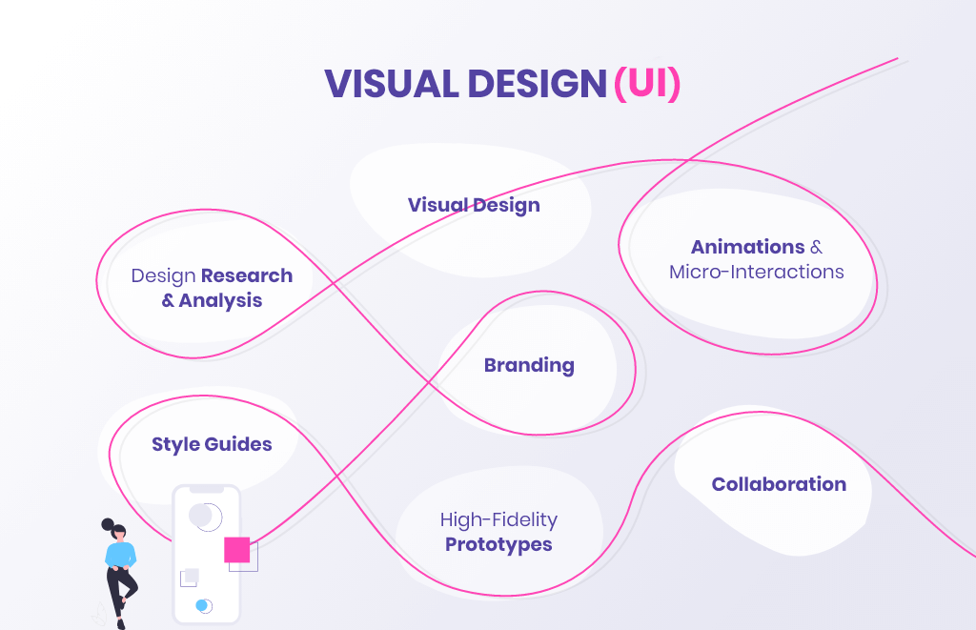

**6. Visual Design (UI)**

This step refers to designing the look and visual elements users experience when interacting with a product. This includes colors, shapes, typography, graphics, icons, buttons, and micro-interactions.

With all the content structure, user flows, and information architecture approved and out of the way, here comes the creative part. Your tasks during this step consist of the following:

**✅ Design research and analysis:** This includes researching the latest web design trends, and finding inspiration.

**✅ Visual design:** Planning and designing all the visual elements of the interface. This includes page layouts, typography, spacing, colors, graphics, icons, buttons, etc.

**✅ Animations and micro-interactions:** Creating animations, hover effects, and transitions.  Also, interactive elements such as buttons, toggles, and drop-down menus.

**✅ Branding:** Implementing brand visual style into the product. This means when working on the interface, you work on color schemes, typography, and other visual elements that correspond to the general brand concept of the product.

**✅ Style guides:** You can also create guides and libraries that include all design elements used for the product and how they should look. These are necessary for the final project documentation.

**✅ Prototypes:** Prepare mockups and high-fidelity prototypes ready for user testing.

**✅ Collaboration:** Work with the developers to implement design into a functional product. The developers need to be sure they can build what you’re suggesting.

And now it’s time for you to prepare all your project files and additional assets. This includes the design files for the desktop version as well as the responsive designs that you’ll hand to the developing team. This leads us to the next step.

**7. Development**

During the coding phase, the developer will recreate your prototypes and you will need to continue collaborating, applying UI changes, and improving the functionality.

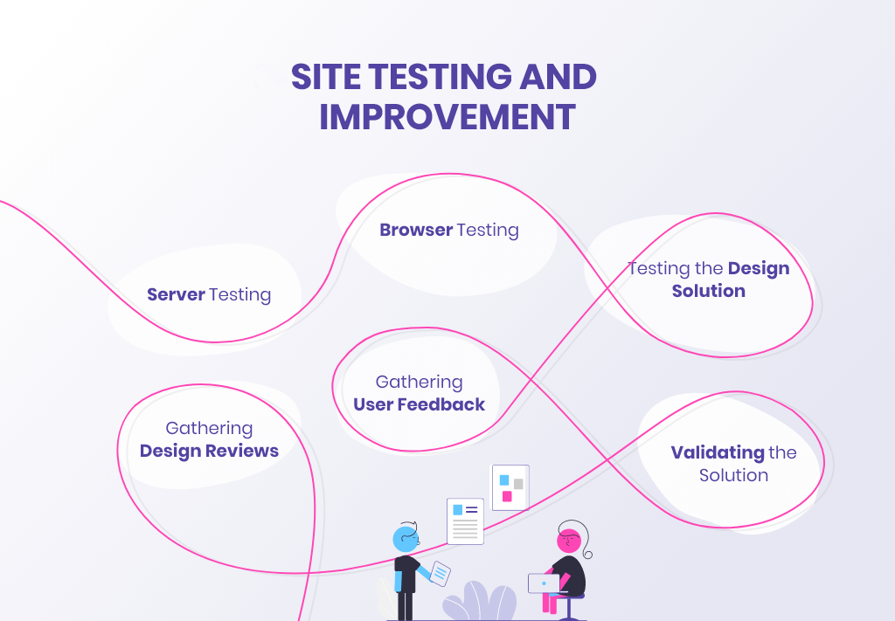

**8.  Site Testing and Improvement**

This step applies mainly to the developers as they need to place the finished website on a production server for internal audiences.

**✅ Testing and Improvement include the following:**

* **Server testing:** The developers place the website on a production server for internal audiences in order to find unforeseen issues they need to address before launching.
* **Browser testing:** The developers will also review the website on multiple browsers and devices to see if any breaks will occur.
* **Testing the design solutions:** Includes usability testing, quality testing, and adjusting requirements.
* **Gathering user feedback and design reviews:**improve your original design and eliminate all previously unforeseen issues and user difficulties.
* **Validating the solution:** Once the stakeholders reviewed and approved the final version of the designed and coded website, you’re ready to launch.

**9. Launch**

When you enter this phase, your team and all stakeholders should have already agreed that the website is ready to launch, you have a contingency plan if things go wrong and the client’s marketing team is prepared for the campaign.

It’s important to remember that launching a website doesn’t necessarily mean that your work here is done. In most cases, the marketing team will handle updating the written content, however, you will still need to prepare to add new elements, and new pages, tweak the design, and ultimately make the website better.

**10. Post-Launch**

With the website going live and reaping success, the development team will still need to address some smaller additional bugs or unexpected behavior. When it comes to design, however, note that user needs and web design trends and practices change over time so may also need to make some adjustments accordingly.

**✅ Post-launch includes the following:**

* **Updates:** Updating content, functionality, design, and software in the long run
* **Fixes:** Applying bug fixes, making changes to the back end, and fixing broken links.

Staying somewhat involved in the post-launch process is that extra step that will never go unnoticed and will be what makes you and your team special. Of course, completely taking responsibility to maintain a website is something else and should be considered an additional service.

**To Sum Up**

Web design processes are circular as they depend on feedback, testing, and improvement, so don’t get discouraged if you need to repeat some of the steps. This is normal. What’s important is to make sure there is a design workflow where every stakeholder is aligned and moving collaboratively to meet milestones.

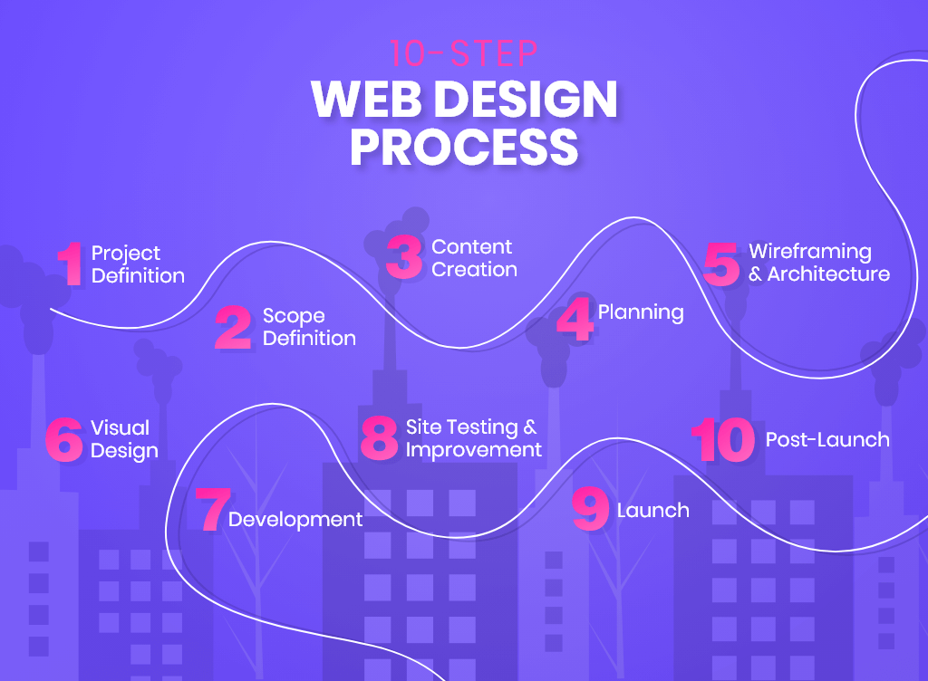

**❌ As well as to avoid the following common mistakes:**

* **Neglecting your collaboration with developers:** Poor communication with the developers can affect the project’s successful completion. The developers need to be sure they can implement your design into a functional product.
* **Missing a CTA:** Make sure that you are being absolutely clear about what you want the visitors to do. The entire design can become pointless if there is no obvious way to close the deal.
* **Forgetting about accessibility:** Take care of your font sizes, styles, and colors to make the design accessible for users with visual impairment. You can always do that extra step to add XL oversize widgets, the option to change contrast, highlight links, pause animations, adjust the line height, change text-align, make the text dyslexia friendly, etc.
* **Your website isn’t mobile-perfect:** Responsiveness is an obvious requirement, however, considering mobile usage has surpassed desktop for shopping, consider going a step further. Unlike responsive design, with this approach, you design the layout specifically for mobile devices and adapt that design for bigger screens later on.